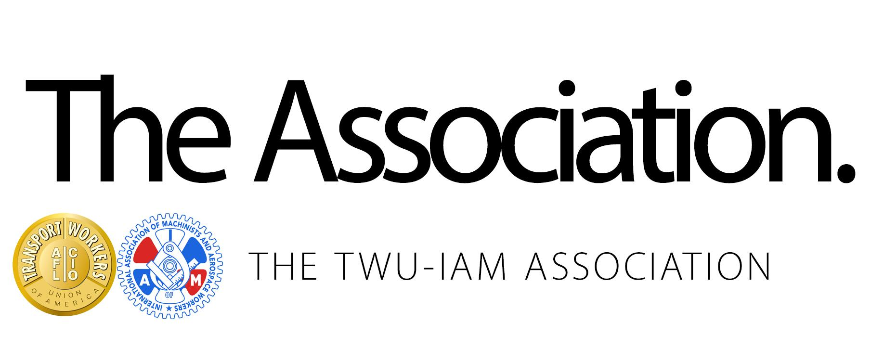

**September 1, 2017**

[**Association, AA Executive Session Negotiations Continue**](http://www.iamdl142.org/association-aa-executive-session-negotiations-continue-7/)

Brothers and Sisters,

After the fallout from the Company’s letter on Friday August 24th, the Executive Negotiating Committee met face to face with American Airlines this week in Washington DC. The ghost negotiators from the Company that were invited to join the talks did not show up. The Association is taking the high road and looking to secure an industry leading contract for our members and did not stoop to the pathetic approach that the Company took last week in trying to negotiate on the shop floor. Instead your Committee arrived ready to continue negotiations in an effort to produce the industry leading agreement you are entitled to.

The Executive Committee and the Company were able to reach tentative agreements on Status of Agreement for all groups, MCT Sick Leave, and have narrowed the issues for the groups in the Classifications and Qualifications articles. Additionally, an agreement was reached for initial aircraft inspections for the maintenance bases. The Negotiating Committee continues to review/modify contract language and give their recommendations to the Executive Committee.

The contractually agreed to Association wage increases due on September 12th, will be provided to all Mechanic & Related, Stores, Maintenance Training Specialists, and Fleet Service members.

The Committee sincerely thanks the membership for their continued support and showing of solidarity during this critical phase of negotiations!

**Negotiations are scheduled to resume on the following weeks:  September 11th Dallas/Fort Worth, October 2nd Washington DC, October 16th New York City. Your Committee is ready and willing to meet anytime - anywhere with the Company to bring you the Industry Leading contract you deserve.**

Fraternally,

***Mechanic and Related/Stores Committee:***

*Jason Best Mike Bush Ken Coley John Coveny Dale Danker Mark Huﬀman*

*Bennie Martino Gary Peterson Rollie Reaves Sean Ryan Jay Sleeman Mark Strength*

[Please Post On All TWU- IAM Bulletin Boards](http://www.iamdl142.org/wp-content/uploads/2017/01/Association-Bulletin-January-13-2017.pdf)